Video Game Sales as Function of Critic Score (Nintendo)

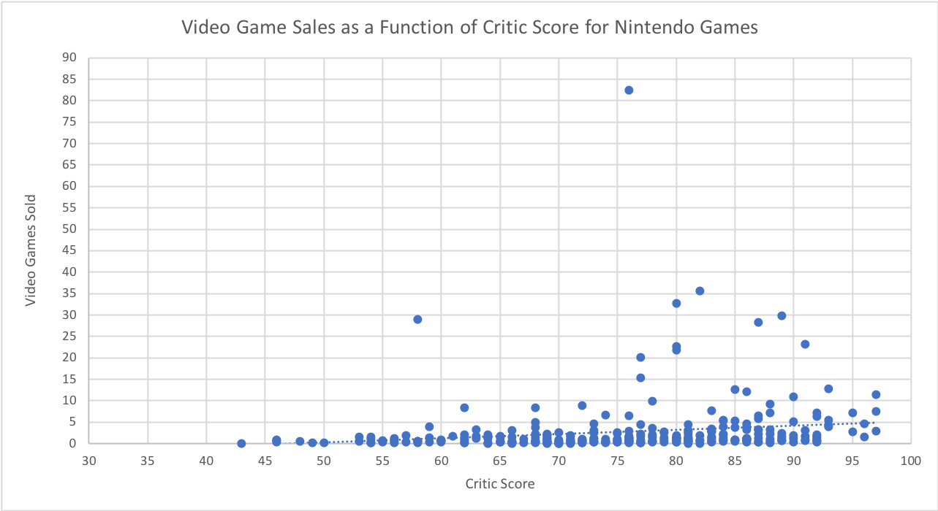

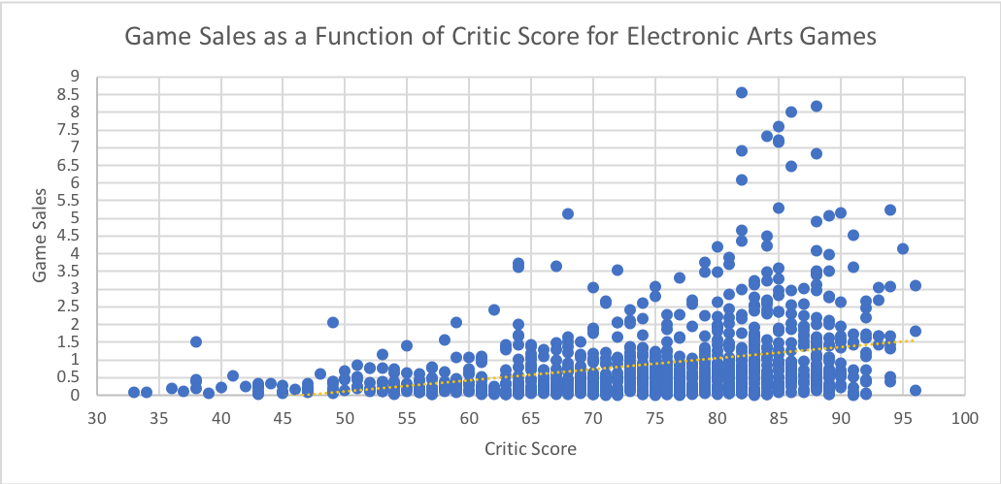

Pivot Table with Games by year (filtered by publisher)

|  |  |
| --- | --- |
| Publisher | (All) |
|  |  |
| **Row Labels** | **Sum of Global_Sales** |
| 1980 | 11.38 |
| 1981 | 35.77 |
| 1982 | 28.86 |
| 1983 | 16.79 |
| 1984 | 50.36 |
| 1985 | 53.94 |
| 1986 | 37.07 |
| 1987 | 21.74 |
| 1988 | 47.22 |
| 1989 | 73.45 |
| 1990 | 49.39 |
| 1991 | 32.23 |
| 1992 | 76.17 |
| 1993 | 48.4 |
| 1994 | 79.18 |
| 1995 | 88.11 |
| 1996 | 199.15 |
| 1997 | 200.98 |
| 1998 | 256.45 |
| 1999 | 251.25 |
| 2000 | 201.58 |
| 2001 | 331.47 |
| 2002 | 395.51 |
| 2003 | 357.8 |
| 2004 | 419.05 |
| 2005 | 458.31 |
| 2006 | 518.22 |
| 2007 | 605.37 |
| 2008 | 671.79 |
| 2009 | 658.88 |
| 2010 | 590.59 |
| 2011 | 507.79 |
| 2012 | 355.84 |
| 2013 | 361.24 |
| 2014 | 331.51 |
| 2015 | 268.05 |
| 2016 | 130.1 |
| 2017 | 0.06 |
| 2020 | 0.29 |
| N/A | 98.96 |
| **Grand Total** | **8920.3** |

If you were to filter it down and make one chart showing this relationship for both Electronic

Arts and Nintendo, this is what you would get.

